47U ENCLOSURE 19" CABINET 600X600 FLOOR STANDING DATA RACK - ECO NETCAB
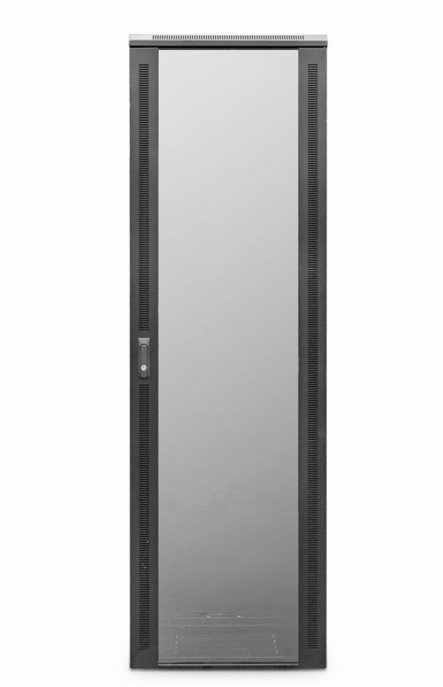

DESCRIPTION
The LMS Data EcoNetCab is the defacto standard in offering great choice and quality enclosure solutions, be it structured cabling for your copper or fibre networking, LAN or WAN networking deployment or broadcast A/V for companies of all sizes. Designed for the installer and IT manager, all enclosure come with useful features to make your installation that much easier, together with bundled free accessories you need to get your new installation up and running.

TECHNICAL SPECIFICATIONS
47U high 600W 600D - *SUPPLIED FLAT PACK ONLY*
• 19" standard
• FLAT PACK ONLY
• Colour: Black (Powder-coated RAL 9005)
• Dimensions: 600 (width) x600(depth) x2320mm (height - inc. castors)
• Front tempered glass door (lockable)
• Left/right hinged front/rear doors
• Removable side panels for easy access
• U-numbered uprights for rack-mount product alignment
• Multiple cable entry glands for exact power and cabling entry
• 2-way fan tray supplied
• Vented shelf supplied

PRODUCT INFO
SKU/MNP: CAB-FE-47U-66
EAN: 8400800031235
Dimensions: 600 (width) x600(depth) x2320mm (height inc. castors) - when assembled

SUPPLIED WITH
Standard/Shipping Castors (Fitted): Set of 4 adjustable Jacking Feet (Supplied): Standard M6 Cage Nuts and Bolts (Supplied): Hex Adjusting Key (Supplied), 2-way fan tray, vented shelf
*NETBIT ONLY DELIVERS THESE CABINETS USING SAME DAY DELIVERY SERVICE - PLEASE CALL FOR DELIVERY QUOTE*

FILES
Specification Sheet (PDF)

